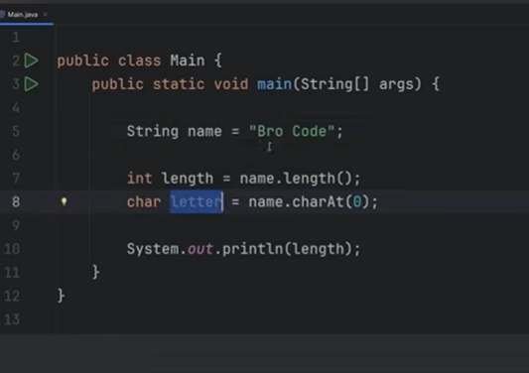
String method length() returns size of word and and charAt() returns character at specified location

Could check if a word is uppercase using uppercase method e.g
for(int i = 0; i<name.length(); i++){
char letter = name.charAt(i);
if(name[i] == letter.isUpperCase()){
System.print.ln(“This letter is upper case”)
} else {
name[i].isUpperCase();
System.out.println(“This character has been converted to upper case”);
System.out.println(name[i]);
}
}
Came up with this on a whim but what it does it that it checks if the character in variable name is uppercase and returns the first statement if it is and if not it goes to else uses string methods isUpperCase() to convert it to an uppercase letter

